RESIDENT GATE PASS SYSTEM
@CREATIVITY THINK (9483175986/7019689991)

ABSTRACT:
The Resident Gate Pass System is a web-based application designed to streamline visitor management in residential societies, offices, and schools. The platform enables residents or employees to request passes, allows administrators to approve or deny requests, and provides detailed visitor analytics through a dashboard. Users can track the status of their pass requests and view historical records, while administrators monitor visitor flow and generate actionable insights. Developed using Django and Django Rest Framework on the backend, and React with Redux and Leaflet on the frontend, the system ensures secure, efficient, and transparent gate management..

INTRODUCTION OF THE PROJECT:
Manual visitor management processes in residential complexes and institutions are often inefficient, prone to errors, and lack transparency. Traditional methods do not provide real-time tracking, analytics, or a systematic approval workflow. The Resident Gate Pass System addresses these challenges by offering a digital, centralized platform that manages pass requests, approvals, visitor history, and analytics. The system improves security, accountability, and operational efficiency, while providing residents and administrators with intuitive interfaces for daily management..

PROJECT OBJECTIVES:

• Allow residents or users to request gate passes easily
• Enable administrators to approve or reject pass requests efficiently
• Track status of pass requests in real time
• Maintain a detailed history of all visitor entries and passes
• Provide dashboards with visitor analytics and insights
• Facilitate secure and organized visitor management
• Reduce manual errors and paper-based workflows
• Support data-driven decision-making through analytics

PROBLEM OF THE STATEMENT:
Many residential societies and institutions rely on manual pass issuance, logbooks, or scattered digital methods, leading to inefficiencies, security gaps, and lack of accountability. Residents cannot track the status of their requests easily, and administrators have no comprehensive analytics to manage visitor flow. The Resident Gate Pass System provides a structured and automated solution to these challenges, enabling secure pass management, tracking, and reporting while improving operational transparency..

MOTIVATION OF THE PROJECT:
• To digitize visitor pass management for residents and organizations
• To streamline approval workflows and reduce administrative effort
• To provide secure, trackable, and auditable visitor records
• To enhance security and operational efficiency of entrances
• To generate real-time dashboards and visitor analytics
• To provide user-friendly interfaces for both residents and administrators
• To replace error-prone manual processes with reliable digital automation

BLOCK DAIGRAM OF PROJECT:

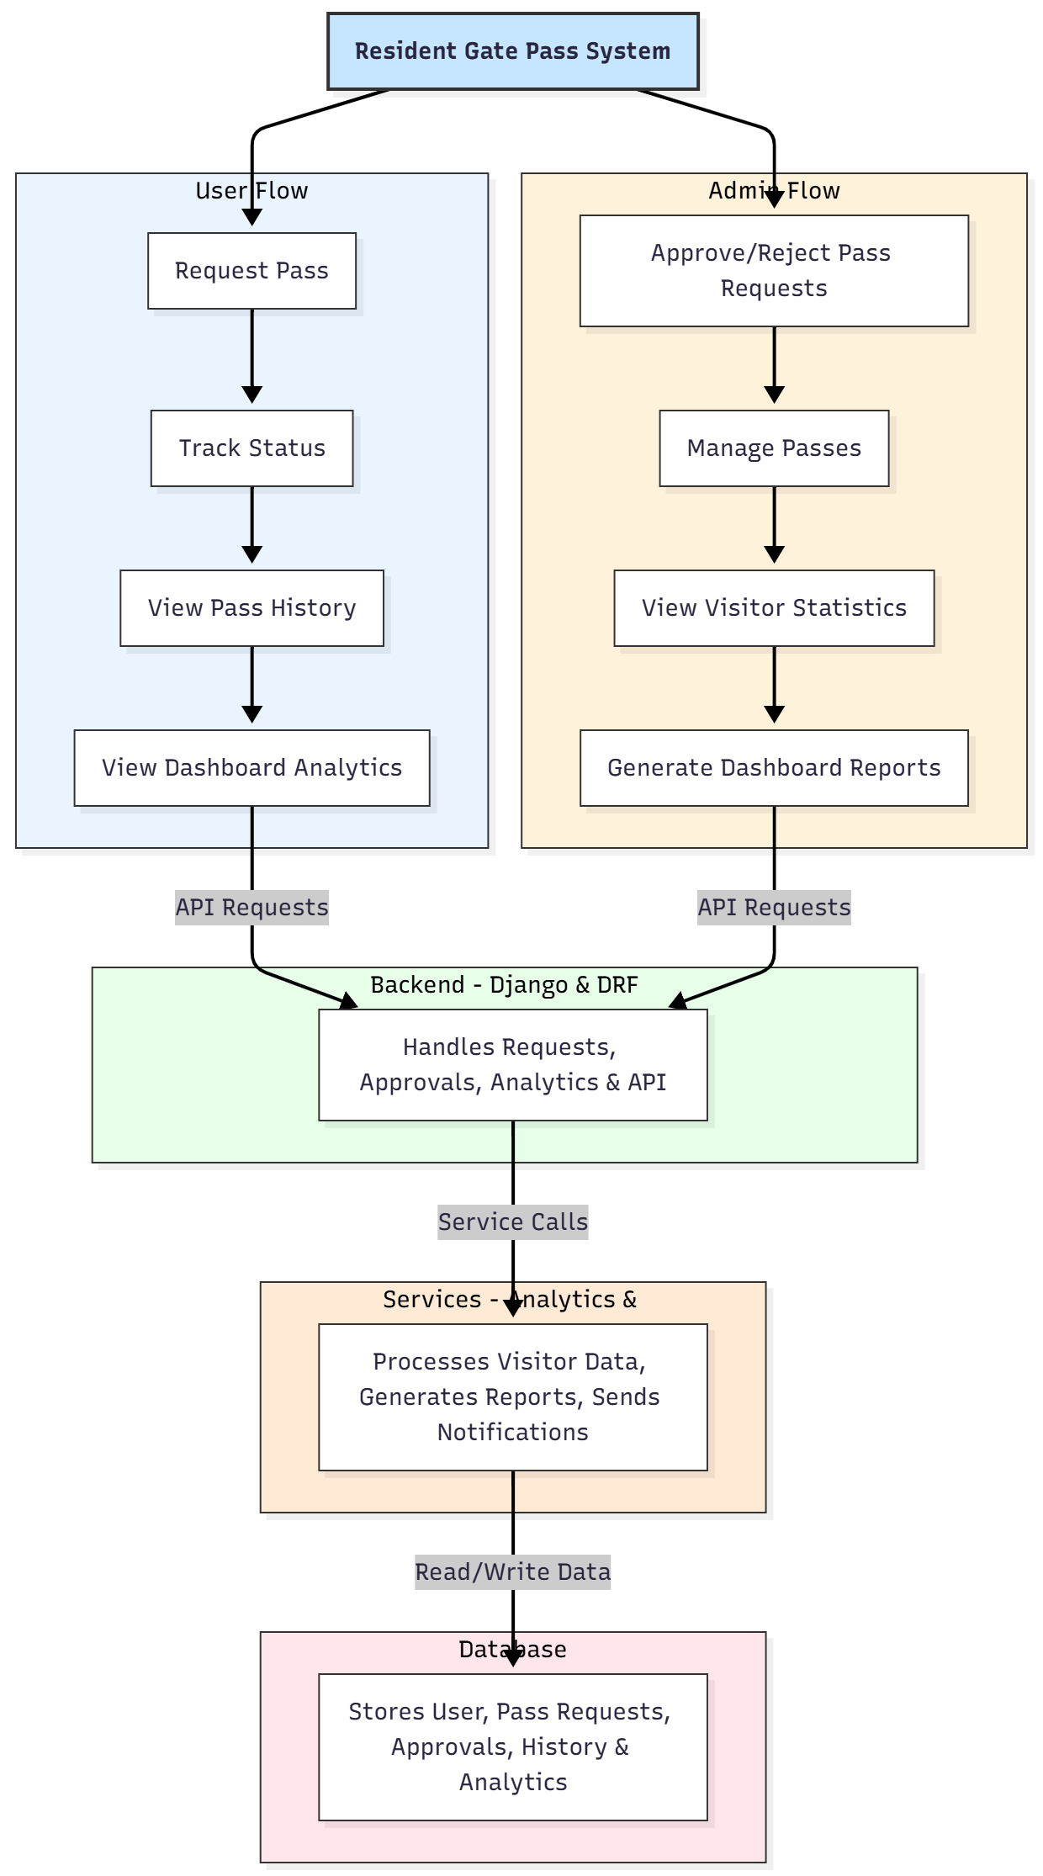

WORKING OF THE PROJECT:
Users start by requesting a gate pass for themselves or a visitor. The backend validates and forwards the request to administrators for approval. Once approved, the user receives confirmation and can track the status of the pass. All requests, approvals, and visitor entries are logged in the database. Administrators can view real-time visitor statistics, monitor history, and generate analytics reports through the dashboard. The services module processes visitor analytics and notifications. The system ensures efficient, secure, and traceable visitor management..

SOFTWARE REQUIREMENT:
- Backend:
  - Python 3.x
  - Django
  - Django REST Framework
  - SQLite/PostgreSQL
- Frontend:
  - Node.js and npm
  - React.js
  - Axios
- Development Tools:
  - Visual Studio Code
  - Postman (for testing APIs)
  - Git/GitHub (for version control)
- Server/Deployment (Optional):
  - Gunicorn, Nginx, or Heroku/AWS for hosting

ADVANTAGES OF THE PROJECT:

• Real-time pass request and approval system
• Centralized visitor history and analytics
• Enhanced security and operational efficiency
• Transparent and auditable records
• Reduces paper-based and manual processes
• Dashboard analytics for informed decision-making
• User-friendly interface for both residents and administrators
• Scalable for multiple housing societies or institutions

APPLICATIONS OF THE PROJECT:
• Housing societies and gated communities
• Office complexes and corporate buildings
• Schools and educational institutions
• Event and visitor management
• Security monitoring for restricted areas
• Administrative tracking and reporting

REFERENCES:

- Django REST Framework Documentation — Django Software Foundation. Django Documentation. Available: https://docs.djangoproject.com/
- Django REST Framework. DRF Documentation. Available: https://www.django-rest-framework.org/
- React. React Official Documentation. Available: https://reactjs.org/docs/getting-started.html
- Redux. Redux Documentation. Available: https://redux.js.org/introduction/getting-started
- PostgreSQL Global Development Group. PostgreSQL Documentation. Available: https://www.postgresql.org/docs/
- MySQL. MySQL Reference Manual. Available: https://dev.mysql.com/doc/
- Git. Git Documentation. Available: https://git-scm.com/doc
- Node.js. Node.js Documentation. Available: https://nodejs.org/en/docs/
- Axios. Axios Documentation. Available: https://axios-http.com/docs/intro
- Socket.io Documentation – https://socket.io/docs/

